SCENT WORK TRIAL CLASS TRANSFER FORM

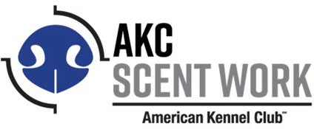
Present this form to the Trial Secretary or the Superintendent at least 30 minutes prior to the start of each trial. Must provide a separate form for each requested transfer.
Move‐up transfers may or may not be available between concurrently held trials. Please see the event Premium list. Transfers are within the same element only.
Transfers can be made for any reason, including the following:
- The dog was mistakenly entered in a higher class for which it was not eligible (move‐down).
- The dog has earned a title and is now eligible for a higher class (move‐up).
- The dog was mistakenly entered in the A section and needs to be moved to the B section (lateral).
Transfers may be approved provided the class is available and has not reached its limit.

Handler’s Name Date

Dog’s Call Name Armband Number

Breed

Class originally entered (ex: Interior Novice A):

Class to be transferred to (ex: Interior Advanced):

Owner’s Name:

Signature of owner or agent Duly
authorized to make this entry:

This completed form should be retained by the Trial Secretary along with the entry forms, for a period of 1 year.

AKC Scent Work Transfer Form Performance Events, Attn: Scent Work 5/2017
8051 Arco Corporate Dr, Ste. 100 Raleigh, NC 27617‐3390

